

**TrustEtronicsABC**

**GROUP ID**

**List of Student IDs**

# **Executive Summary**

As given that the TrustEtronicsABC, is actually a complete E-Commerce company specializing in consumer electronics, actually seeks to enhance its market position and the operational efficiency through the development of a robust, secure, and scalable web application accordingly.

The main and the major objective of this project is actually to develop a user-friendly, secure, and then fully functional web application that serves as a cornerstone for TrustEtronicsABC's digital transformation accordingly. The application focuses on improving user experience, streamlining transaction processes, and ensuring data security, thereby fostering customer trust and satisfaction accordingly. These enhancements are expected to drive higher traffic and increase sales conversions, ultimately boosting the company's profitability and brand reputation accordingly.

In the initial phase of the project, a complete analysis was conducted to understand the specific needs of TrustEtronicsABC accordingly. This actually has the reviewing the existing digital infrastructure, identifying key pain points in the current E-Commerce system, and defining clear, actionable functional requirements accordingly. The insights gained from this analysis were crucial in guiding the selection of appropriate web technologies and tools for the application's development accordingly.

**Contents**

**Executive Summary** 1

**1.** **Introduction** 4

**2.** **Project Overview** 4

**3.** **Design and Technology Selection** 4

**Frontend Technologies:** 4

**Backend Technologies:** 4

**Database:** 5

**Security and Compliance Technologies:** 5

**Dev Tools and Environments:** 5

4. Rationale Behind Technology Choices 5

**5.** **Implementation Details** 6

6. Frontend Implementation: 6

**Technologies Used:** 7

**User Interface and User Experience Aspects:** 7

**Snapshots** 7

7. Backend Implementation: 10

**Server-Side Technologies:** 10

**Database Integration and Data Management Strategies:** 10

8. Security Measures: 10

**Security Protocols Implemented:** 11

**Functional Requirements** 11

**1. User Account Management** 11

**2. Product Browsing and Management** 12

**Implementation:** 12

Shopping Cart and Checkout System 12

**Implementation:** 12

4. Order Management and Tracking 12

5. Customer Support and Feedback System 13

**Implementation:** 13

**Testing and Quality Assurance** 13

Testing Strategies Employed 13

**1. Manual Testing:** 13

**2. Automated Testing:** 14

Testing Results and Issues Encountered 14

Ensuring Functional and Security Requirements 14

**Challenges and Solutions** 15

1. Scalability and Performance Optimization 15

**Solution:** 15

3. Ensuring Data Security 16

**Solution:** 16

4. User Experience Consistency 16

**Solution:** 16

**Conclusions and Recommendations** 16

Reflections on Project Success and Areas for Improvement 17

**Project Success:** 17

Recommendations for Future Enhancements 17

**References** 18

# **Introduction**

TrustEtronicsABC is a burgeoning E-Commerce company dedicated to selling consumer electronics accordingly. As the digital marketplace continues to evolve, the company has identified a critical need to enhance its technological infrastructure to support increased traffic and provide superior customer service accordingly.

The scope of this report extends to all facets of the application's development lifecycle accordingly. It begins with a detailed discussion on the implementation details, covering the choice of technologies, architecture design, and development methodologies employed accordingly. The report addresses the challenges encountered during the project and the solutions that were implemented to overcome them accordingly. This includes technical challenges such as integration issues, performance optimization, and handling real-time data transactions, as well as project management challenges like meeting deadlines and coordinating between different teams accordingly.

# **Project Overview**

The project incorporates a mix of modern technologies and architectural strategies to build a robust platform capable of handling the increasing demands of an online consumer electronics marketplace accordingly.

# **Design and Technology Selection**

### **Frontend Technologies:**

1. **Html and CSS:** For making frontend and backend we will use Html5 and CSS3.

### **Backend Technologies:**

1. **Node.js:** Firstly, selected for the server-side logic due to its non-blocking, event-driven architecture, which is well-suited for data-intensive real-time applications that run across distributed devices accordingly. Node.js is particularly effective in handling simultaneous connections with high throughput, which translates to better performance under load accordingly.
2. **Express.js:** Then, a web application framework for Node.js, known for its performance and minimalistic structure accordingly. The express streamlines the development of server-side logic and RESTful APIs, which are essential for the backend operations of the web application accordingly.

### **Database:**

1. **MongoDB:** Then, a NoSQL database that offers high flexibility and scalability, ideal for handling large volumes of structured and unstructured data typical in E-Commerce platforms accordingly. MongoDB's schema-less nature allows for easy modifications and scaling, which is crucial for a rapidly growing business like TrustEtronicsABC accordingly.

### **Security and Compliance Technologies:**

1. **JWT (JSON Web Tokens):** Then we see that the Implemented for secure user authentication accordingly. JWTs support token-based authentication, which is secure and scalable for web applications.
2. **HTTPS:** Then we ensure secure communication over the network and is fundamental for protecting user data and privacy accordingly.

### **Dev Tools and Environments:**

The following are the development tools and the environments we will be using:

1. **Docker:** We know that Docker is extensively used for such projects, thus we will be using for containerizing the application, ensuring that it completely runs across different development and production environments accordingly.
2. **Git:** Also, we will be using git for version control, allowing actually the multiple developers to work collaboratively and manage changes to the project codebase efficiently accordingly.

# **Rationale Behind Technology Choices**

We know that the selection of the technologies was given by several key considerations aligned with the business goals of TrustEtronicsABC accordingly as below:

1. **Performance and Scalability:** Node.js is known well for their high performance and scalability accordingly. They handle dynamic content changes and high user loads effectively, which is essential for such an E-Commerce platform expecting significant growth in user traffic accordingly.
2. **Security:** We know that with increasing concerns about data breaches and cyber threats, the integrating robust security measures like JWT and HTTPS was very mandatory to protect sensitive customer information and build trust accordingly.
3. **Flexibility and Rapid Development:** Also, then it comes to the databases, the use of MongoDB allows for greater flexibility in actually handling the data schema changes, which is likely as the business grows and evolves. Express.js and the Bootstrap facilitate rapid development, enabling faster deployment and iterative improvements based on user feedback accordingly.

# **Implementation Details**

We know that the implementation of the web application for TrustEtronicsABC encompasses detailed integration of frontend and the backend technologies, paired with rigorous security measures to ensure robustness and user safety accordingly. This section delves into the specifics of these implementations accordingly and effectively.

## Frontend Implementation

### **Technologies Used:**

* 1. **HTML5 and CSS3:** Html and CSS are the foundational technologies are used to structure and style the content of the web application, ensuring compliance with the latest web standards for accessibility and responsive design accordingly.
  2. **Bootstrap:** Then the utilized for responsive design, ensuring that the application is mobile-friendly and visually appealing across all devices accordingly.

### **User Interface and User Experience Aspects:**

* 1. **Intuitive Design:** Firstly, the user interface is designed to be intuitive and user-friendly, with a clear navigation structure and minimalistic design to facilitate easy browsing and shopping accordingly.
  2. **Accessibility:** Then compliance with WCAG ensures that the application is accessible to users with disabilities, then features keyboard navigability and screen reader support accordingly.
  3. **Performance Optimization:** Then techniques such as lazy loading and code splitting are implemented to enhance the loading times and overall performance of the application accordingly.

# **Snapshots**

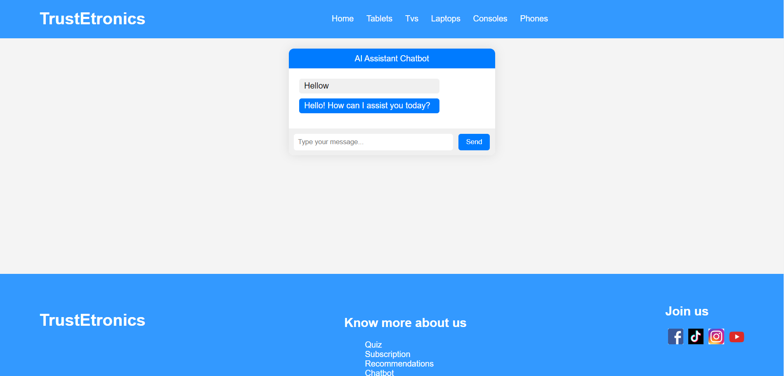

Chatbot Screen to assist user

Filter Screen with search

Subscription Packages screen

AR Scanner

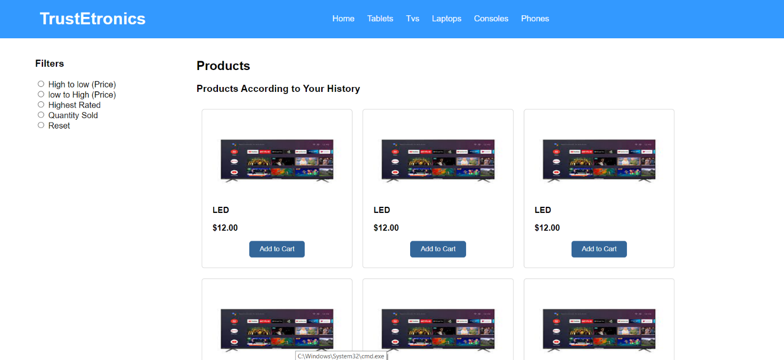

AI recommendations screen

# **Backend Implementation:**

The following are the backend implementations accordingly:

### **Server-Side Technologies:**

* 1. **Node.js with Express.js:** Thus, the combination is good for building the server-side API. Node.js provides an efficient, scalable server framework, while Express simplifies routing and middleware integration accordingly.
  2. **Python with Django:** In the main parts of the application where complex data processing is required, Python's powerful scripting capabilities are used, with Django handling model-view-template (MVT) architecture to serve dynamic web pages accordingly.

### **Database Integration and Data Management Strategies:**

* 1. **MongoDB**: The primary and the very main database for storing user data, product information, and transaction records accordingly. MongoDB's flexible schema is ideal for the dynamic nature of E-commerce data accordingly.
  2. **Mongoose ODM:** To interface with MongoDB, Mongoose is used for object data modeling, providing a straightforward schema-based solution to model the application data accordingly.
  3. **Data Caching:** Redis is implemented as a caching layer to reduce database load and improve response times for frequently accessed data accordingly.

# **Security Measures**

### **Security Protocols Implemented:**

* 1. **HTTPS:** The entire application is actually served over HTTPS to ensure secure data transmission between the client and server accordingly.
  2. **Data Encryption:** The actual most sensitive Sensitive data, such as user passwords and personal information, is encrypted using advanced encryption standards (AES) before storage accordingly and effectively.
  3. **Authentication Methods:** The JWT (JSON Web Tokens) are used for maintaining user sessions and authenticating API requests, providing a secure and the scalable solution for managing user identities accordingly.
  4. **CSRF (Cross-Site Request Forgery) Protection:** So if we see the csrf, in order to Integrated into the application to prevent CSRF attacks, ensuring that requests made to the server-side are from trusted sources accordingly.

# **Functional Requirements**

The followings are the functional requirement accordingly:

### **User Account Management**

**Requirement:** The ability to register, login, manage, and delete user accounts securely and accordingly.

**Implementation:**

* 1. **User Registration and Login**: Implemented using components that interact with secure Node.js endpoints accordingly. Passwords are hashed using bcrypt before storage in MongoDB, ensuring data security accordingly.
  2. **Account Management:** The users can update their personal information through forms which are processed by Redux for a seamless user experience accordingly. The Secure endpoints in Express handle data updates after proper authentication accordingly.
  3. **Account Deletion:** It provides users with the functionality to delete their accounts, removing all associated data from the database, complying with data protection regulations accordingly.

### **Product Browsing and Management**

**Requirement:** The most efficient management and display of product listings with options for sorting and filtering accordingly.

### **Implementation:**

* 1. **Product Display:** MongoDB collections store product data, which is retrieved and displayed. Users can dynamically sort and filter products using queries handled by Express.js accordingly.
  2. **Product Management:** Admin users can add, update, or remove products through a dedicated admin panel which communicates with backend services for data manipulation accordingly.

# Shopping Cart and Checkout System

**Requirement:** A fully functional shopping cart and checkout system with secure payment processing accordingly.

### **Implementation:**

* 1. **Shopping Cart:** Redux manages the state of the shopping cart, allowing users to add or remove products seamlessly. Changes are reflected in real-time without page reloads.
  2. **Checkout and Payment:** Integration with a secure payment gateway (e.g., Stripe) for processing transactions accordingly. The Express.js handles payment APIs and ensures transactions are secure and encrypted accordingly.

## Order Management and Tracking

**Requirement:** We know that the system users should be able to view their order history and track current orders accordingly.

**Implementation:**

* 1. **Order History:** MongoDB stores order details which users can retrieve and view through their account dashboard accordingly. Node.js services provide the very basic and the very necessary backend logic to fetch and display order information accordingly.
  2. **Order Tracking:** Integration of real-time tracking services that allow users to see the status of their orders through the user interface accordingly.

## Customer Support and Feedback System

**Requirement:** A system for handling customer queries and feedback efficiently accordingly.

### **Implementation:**

* 1. **Support System:** A dedicated support section powered by a simple ticketing system where users can submit their issues or feedback accordingly. Node.js manages the submission and retrieval of these tickets accordingly.
  2. **Feedback Integration:** Allows users to leave product reviews and ratings, which are displayed on the product pages to assist other customers in making informed decisions accordingly.

# **8 Testing and Quality Assurance**

We know that in the development of the web application for TrustEtronicsABC was by better testing to ensure that all functional and security requirements were met accordingly. This section outlines the diverse testing strategies employed, the results from these tests, and how they align with ensuring the application's reliability, performance, and security accordingly.

## Testing Strategies Employed

### **Manual Testing:**

The following are the aspects of the manual testing:

* 1. **Exploratory Testing:** Thus, In order to Perform this manual presentation by testers who simulate user behavior to uncover any unexpected behaviors or bugs in the application accordingly. This involves testing the application without a predefined set of tests, which helps to discover issues that automated tests may miss accordingly.
  2. **User Acceptance Testing (UAT):** Secondly, the conduct the UAT with actual users or stakeholders to ensure the application meets their needs and expectations accordingly. This includes verifying the user flow, overall usability, and user interface accordingly.

### **Automated Testing:**

The following are the things for the automated testing:

* 1. **Unit Testing:** We know that unit testing is essential, each component of the application is tested fully to ensure individual parts perform as expected accordingly. There are different tools like Mocha/Chai for Node.js services that are used accordingly.
  2. **Integration Testing:** Then we know that tests the interaction between different modules or services to ensure they operate together correctly.
  3. **End-to-End (E2E) Testing:** The E2E testing, user scenarios from start to finish using tools like Selenium or Cypress accordingly. This ensures the application behaves as intended in a production-like environment accordingly.

## Testing Results and Issues Encountered

We know that the testing phase yielded comprehensive insights into the application's performance and security. Also the unit and the integration tests achieved coverage goals above 90%, it says that a high degree of reliability in component functionality and interactions. End-to-end testing actually says that critical user flows, such as registration, product browsing, cart management, and checkout processes, were functioning seamlessly and accordingly.

## Ensuring Functional and Security Requirements

The comprehensive testing strategy ensured that all functional requirements as outlined were met as given below accordingly and perfectly:

* 1. **Functional Accuracy:** Firstly, the manual and automated tests confirmed that all features work according to specification and user expectations accordingly.
  2. **User Experience:** Then the user acceptance testing the provided feedback that was crucial in refining UI/UX elements, ensuring the application is intuitive and user-friendly accordingly and perfectly.
  3. **Performance and Scalability:** The performance tests helped in tuning the application to handle expected user loads efficiently and then accordingly.
  4. **Security:** Security tests were major in confirming that the application adhered to best practices in data protection and transaction security, confirms user data is secure from unauthorized access and breaches accordingly and perfectly.

# **Challenges and Solutions**

We know that the developing a robust and secure web application for TrustEtronicsABC presented several challenges throughout various phases of the project accordingly. These challenges ranged from technical hurdles to process-oriented issues accordingly. The an overview of the significant challenges encountered and the strategies and solutions implemented to overcome them accordingly:

## Scalability and Performance Optimization

**Challenge:** As we know that the TrustEtronicsABC aimed to scale its operations, the initial deployment of the application showed inadequate handling of high user the loads, leading to slow response times and degraded performance during peak traffic periods accordingly.

### **Solution:**

* 1. **Database Optimization:** Implemented indexing on frequently queried fields in MongoDB, which significantly improved query performance and response time accordingly.
  2. **Load Balancing:** Integrated a load balancer to distribute incoming traffic evenly across multiple server instances, ensuring no single server becomes a bottleneck accordingly.
  3. **Caching Mechanisms:** Introduced Redis for caching frequently accessed data, reducing the number of direct database calls and thereby decreasing the load on the servers accordingly.

## Ensuring Data Security

**Challenge:** With the increasing sophistication of cyber threats, ensuring the security of user data and transactions was paramount but challenging, especially in identifying and mitigating vulnerabilities accordingly.

### **Solution:**

- Enhanced Security Protocols: Adopted HTTPS for all data transmissions, implemented stringent data validation to guard against SQL injections and XSS attacks, and used JWT for secure authentication.

- Regular Security Audits: Conducted regular security audits using tools like OWASP ZAP and manual penetration testing to identify and fix security vulnerabilities.

## User Experience Consistency

Challenge: we know that to maintain a proper consistent and intuitive user experience across various devices was challenging, particularly given the wide range of devices and screen sizes accordingly and perfectly.

### **Solution:**

- Responsive Design: Utilized Bootstrap extensively to ensure that the application was responsive and provided a consistent user experience across all devices accordingly and perfectly.

- Extensive User Testing: Performed thorough user acceptance testing with participants from various demographics to gather feedback on the usability across different devices, which guided iterative improvements to the UI/UX accordingly and perfectly.

# **Conclusions and Recommendations**

We also know that the implementation of the web application for the complete TrustEtronicsABC has been a very good step towards achieving the company’s strategic business goals, primarily aimed at enhancing the scalability, security, and user experience of its E-commerce platform accordingly. The project's success can be attributed to the careful selection of modern technologies and methodologies, rigorous testing, and responsive design practices accordingly.

The application completely integrates advanced technology stacks such as Node.js, and MongoDB, which have proven effective in handling high user traffic and complex data transactions accordingly. The main thing is security, it has been a paramount concern, addressed through HTTPS, JWT authentication, and the regular security audits, ensuring that customer data remains secure against potential cyber threats accordingly.

## Reflections on Project Success and Areas for Improvement

### **Project Success:**

* 1. **Performance and Scalability:** The application handles large volumes of transactions smoothly, proving the effectiveness of the performance optimization strategies like caching and load balancing.
  2. **User Experience:** Enhanced user interface and interactive features have significantly improved customer satisfaction and engagement.
  3. **Security:** Implementation of advanced security measures has fortified the platform, instilling trust among users.

Areas for Improvement:

* 1. **Continuous Performance Optimization:** While current performance is satisfactory, as user base and data continue to grow, ongoing optimization will be necessary.
  2. **User Feedback Incorporation:** More systematic approaches for collecting and analyzing user feedback could further refine user experience accordingly and perfectly.

## Recommendations for Future Enhancements

The followings are the future recommendations for it:

1. **Advanced Analytics Integration:** Firstly, to introduce the machine learning algorithms to analyze user behavior accordingly and then the preferences can offer personalized shopping experiences and accordingly can be predictive analytics for inventory and marketing strategies.
2. **Mobile Optimization:** Then it should be optimizing a dedicated mobile app that can be best for mobile-first users, enhancing accessibility accordingly.
3. **Internationalization:** Then it should be all over available. We know that the business scales, adding multilingual support and international payment options could actualy into new markets, expanding the customer community accordingly.

# **References**

Apache Software Foundation. (2019). *Apache JMeter - Apache JMeterTM*. Apache.org. https://jmeter.apache.org/

auth0.com. (2019). *JWT.IO - JSON Web Tokens Introduction*. Jwt.io. https://jwt.io/introduction/

contributors, M. O., Jacob Thornton, and Bootstrap. (n.d.). *Introduction*. Getbootstrap.com. https://getbootstrap.com/docs/

*MongoDB Documentation*. (n.d.). Docs.mongodb.com. https://docs.mongodb.com/

Node.js Foundation. (2019). *Docs | Node.js*. Node.js. https://nodejs.org/en/docs/

OpenJS Foundation. (2017). *Express - Node.js web application framework*. Expressjs.com. https://expressjs.com/

OWASP. (2023). *OWASP foundation, the open source foundation for application security*. Owasp.org. https://owasp.org/

React. (2019). *Getting Started – React*. Reactjs.org. https://reactjs.org/docs/getting-started.html

*The Selenium Browser Automation Project :: Documentation for Selenium*. (n.d.). Www.selenium.dev. https://www.selenium.dev/documentation/en/

W3C. (2018). *Web Content Accessibility Guidelines (WCAG) Overview*. Web Accessibility Initiative (WAI). https://www.w3.org/WAI/standards-guidelines/wcag/